Modification in first improvement 2-opt local search to speed up

http://tsp-basics.blogspot.com/2017/03/using-dont-look-bits-dlb-2-opt.html

Search references for this method

Chosen instances:

|  |  |  |
| --- | --- | --- |
| Instance name | Instance size | Instance size group |
| pr439.tsp | 439 | small |
| d657.tsp | 657 | small |
| rl1889.tsp | 1889 | medium |
| d2103.tsp | 2103 | medium |
| d15112.tsp | 15112 | large |

First step, record the time taken by each instance to execute 200 iterations of GRASP using the configuration RDSNN + first, alpha = 10.

./tspProblem alpha_adjust_10 RDSNN first 1 folder instances/adjustment 0 ql 2 200 10

|  |  |  |  |  |
| --- | --- | --- | --- | --- |
| Instance name | Instance size | Instance size group | Time for 200 iterations (s) | Best solution |
| pr439.tsp | 439 | small | 1.720725 | 116231 |
| d657.tsp | 657 | small | 3.905633 | 54970 |
| rl1889.tsp | 1889 | medium | 38.307487 | 366618 |
| d2103.tsp | 2103 | medium | 49.87917 | 96627 |
| d15112.tsp | 15112 | large | 4943.36207 | 1823628 |

Time for other alphas calculated by averaging time for each size group.

Small: 3 seconds

Medium: 44 seconds

Large: 4900 seconds

Next step:

Execute GRASP for Alpha = 25, 50, 75, 100 for the same instances, for each obtained average time. Record the best distance obtained for each instance

Scripts:

./tspProblem alpha_adjust_small RDSNN first 1 folder instances/adjustment/small 0 ql 1 3 25 100 25

./tspProblem alpha_adjust_medium RDSNN first 1 folder instances/adjustment/medium 0 ql 1 44 25 100 25

./tspProblem alpha_adjust_large RDSNN first 1 folder instances/adjustment/large 0 ql 1 4900 25 100 25

|  |  |  |  |  |
| --- | --- | --- | --- | --- |
| Instance name | Instance size | Instance size group | Best alpha | Best solution |
| pr439.tsp | 439 | small | 25 | 115670 |
| d657.tsp | 657 | small | 25 | 54427 |
| rl1889.tsp | 1889 | medium | 75 | 361506 |
| d2103.tsp | 2103 | medium | 50 | 96101 |
| d15112.tsp | 15112 | large | 10 | 1823628 |

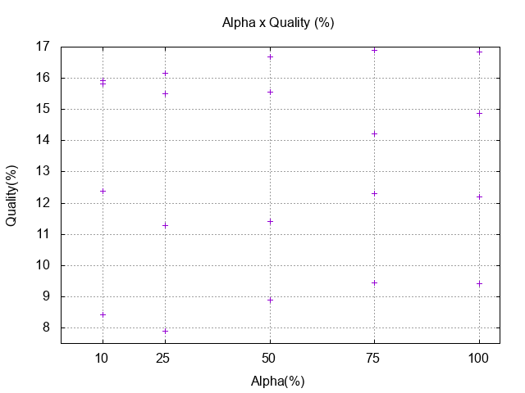

We choose alpha = 25, since it looks the give the best average results among these 5 instances.